**DAILY ONLINE ACTIVITIES SUMMARY**

|  |  |  |  |  |  |  |  |
| --- | --- | --- | --- | --- | --- | --- | --- |
| **Date:** | **17/06/2020** | | | | **Name:** | Tushit Shukla | |
| **Sem & Sec** | **4 SEM & B SEC** | | | | **USN:** | **4AL18CS093** | |
| **Online Test Summary** | | | | | | | |
| **Subject** | | - | | | | | |
| **Max. Marks** | | - | | **Score** | | - | |
| **Certification Course Summary** | | | | | | | |
| **Course** | **PYTHON PROGRAMMING** | | | | | | |
| **Certificate Provider** | | | **Great Learning** | **Duration** | | | **1.5 hr(spent by me on that day to learn)** |
| **Coding Challenges** | | | | | | | |
| **Problem Statement:**  1 Given a number n, write a function that returns count of numbers from 1 to n that don’t contain digit 3 in their decimal representation. **Examples:** **Input:** n = 10 **Output:** 9 Here input is 10 means the numbers within 10 are 1,2,3,4,5,6,7,8,9,10 in this series 3 occurs only 1 times so answer is 9  **More examples** Input: n = 45 Output: 31 // Numbers 3, 13, 23, 30, 31, 32, 33, 34, // 35, 36, 37, 38, 39, 43 contain digit 3.  Input: n = 578 Output: 385 | | | | | | | |
| **Status: Completed** | | | | | | | |
| **Uploaded the report in Github** | | | | **Yes** | | | |
| **If yes Repository name** | | | | <https://github.com/tushitshukla29/lockdown-program> | | | |
| **Uploaded the report in slack** | | | | **Yes** | | | |

**Online Certification Details**

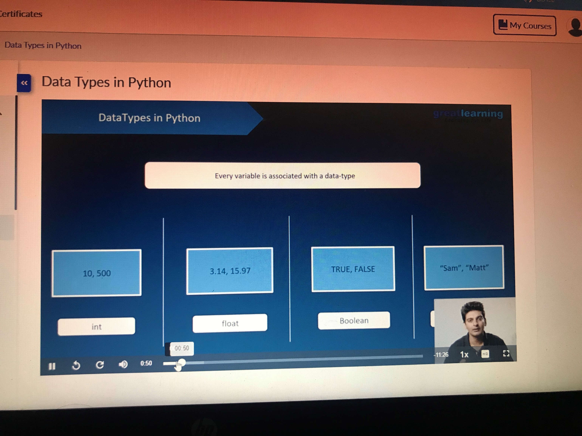

**Coding Challenge Details**

1. <https://github.com/tushitshukla29/lockdown-program/blob/master/counternumber>